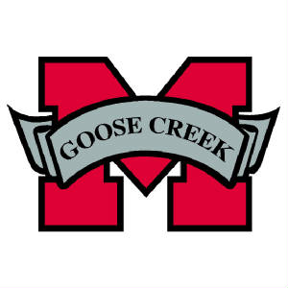
2017 GCM Project Graduation

What is Project Graduation? Project Graduation is a night that seniors and their guest spend in a substance free environment. Project Graduation will take place the night of graduation, May 27, 2017. Students who attend MUST stay the entire night.

Project Graduation will be held at Goose Creek Memorial High School. There will be numerous activities planned throughout the night, possible activities a photo booth, mechanical bull, basketball, volleyball, caricature artist, a hypnotist, pool & ping pong tables, various inflatables (obstacle run, bungee run, hoop shot, etc.) and there will be plenty of food, drinks, and snacks. Seniors will also have the opportunity to win some great prizes during the night.

Several fundraisers have been planned (and we invite you to share your fundraising ideas with us) to help each senior reach one of the prize levels listed below.

A detailed project graduation information packet and contract that senior students must sign will be distributed in the spring. However, below is the information for each level so you and your senior can decide which level they would like to achieve, along with the amount of tickets they will receive the night of Project Graduation to use in the raffle for prizes.

- Patriot Level – To achieve Patriot Level senior student or parent must raise $650.00 by fundraising or obtaining donations. They will receive 55 tickets + a Grand Prize and their guest will get in for free. All seniors at this level are guaranteed a Grand Prize!

- Silver Level – To achieve Silver Level, senior student or parent must raise $325.00 byfundraising or obtaining donations. They will receive 30 tickets and must pay $25.00 for their guest

- Red Level – To achieve Red Level, senior student or parent must raise $150.00 by fundraising or obtaining donations. They will receive 15 tickets and must pay $25.00 for their guest

- Black Level – To achieve Black Level, senior student or parent must raise $100.00 by fundraising or obtaining donations. They will receive 8 tickets and must pay $25.00 for their guest

Seniors who do not participate in any fundraisers will be required to pay an entry fee in order to attend and they will not be eligible to receive any tickets for prizes. Guest cannot be another GCM Senior.

In order for parents to volunteer/supervise at Goose Creek Memorial the night of Project Graduation, they must have attended three Project Graduation meetings and worked at three events.

Contact information for 2017 GCM Project Graduation:

Email: GCM2017ProjectGrad@gmail.com (To join our email list send an email including your name and student name)

Facebook Page: https://www.facebook.com/GCM2017ProjGrad/

Twitter Page: https://twitter.com/GCM2017ProjGrad @GCM2017ProjGrad

Website: http://gcm17projectgrad.weebly.com

SnapChat: gcm2017projgrad

Remind 101: remind.com/join/2017GCM

President: Kim Davis 832-457-7659

