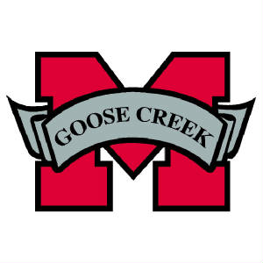
2017 GCM Project Graduation
Volunteer Hour/Donation/Student Credits Information
What is Project Graduation? Project Graduation is a night that seniors and their guest spend in a substance free environment. Project Graduation will take place the night of graduation, May 27, 2017.

Project Graduation will be held at Goose Creek Memorial High School. There will be numerous activities planned throughout the night, possible activities a photo booth, mechanical bull, basketball, volleyball, caricature artist, a hypnotist, pool & ping pong tables, various inflatables (obstacle run, bungee run, hoop shot, etc.) and there will be plenty of food, drinks, and snacks. Seniors will also have the opportunity to win some great prizes during the night.

Several fundraisers have been planned (and we invite you to share your fundraising ideas with us.

Volunteer hours will be calculated per the listing below:

For every four (4) hours worked by either method listed below, by Senior/Parent/Guardian/Family Member, the Senior will received one (1) additional prize ticket: (if a parent/guardian/family member has multiple seniors, then a family member per senior must work)

- Physical setup of the event
- Work during the event
- Tear down of the event
- At school working during lunch, hand out items/take up items

Donation – at various time throughout Project Graduation donations will be needed. We will need all to help out where can. If you volunteer to donate an item(s) than you donation will be greatly appreciated. If you volunteer to donate, it is not mandatory that the donation is funded by the individual if the individual can get someone to donate, i.e. business, etc., then by all means obtain help from those folks.

Credit towards “Levels” – each fundraiser will be explained as the fundraiser approaches. It is a “rule of thumb”, if selling an item, for example candy, the profit of the candy sold will be credited towards the students “account”. Candy is $2.00/bar, Project Graduation makes $1.00/bar, and therefore the student will receive $1.00/bar credit. Spirit nights, tournaments, etc. will go into the “General” fund. More information per fundraiser will be explained as the fundraiser approaches.

Contact information for 2017 GCM Project Graduation:

Email: GCM2017ProjectGrad@gmail.com (To join our email list send an email including your name and student name)

Facebook Page: https://www.facebook.com/GCM2017ProjGrad/

Twitter Page: https://twitter.com/GCM2017ProjGrad @GCM2017ProjGrad

Website: http://gcm17projectgrad.weebly.com

SnapChat: gcm2017projgrad

Remind 101: remind.com/join/2017GCM

President: Kim Davis 832-457-7659

